# **Integration of JMeter with Jenkins**

In this tutorial, we are going to learn how we can integrate ***JMeter with Jenkins***.

***Table of Contents***

1. [***Why do we need to integrate JMeter with Jenkins?***](https://qaautomation.expert/2023/07/07/integration-of-jmeter-with-jenkins/#why-do-we-need-to-integrate-jmeter-with-jenkins)
2. [***Implementation Steps***](https://qaautomation.expert/2023/07/07/integration-of-jmeter-with-jenkins/#implementation-steps)
3. [***Download Performance Plugin***](https://qaautomation.expert/2023/07/07/integration-of-jmeter-with-jenkins/#download-performance-plugin)
4. [***Create a JMeter Script***](https://qaautomation.expert/2023/07/07/integration-of-jmeter-with-jenkins/#create-a-jmeter-script)
5. [***Create a new FreeStyle project***](https://qaautomation.expert/2023/07/07/integration-of-jmeter-with-jenkins/#step-1-create-a-new-freestyle-project)
6. [***Source Code Management***](https://qaautomation.expert/2023/07/07/integration-of-jmeter-with-jenkins/#step-2-source-code-management)
7. [***Select Execute Windows batch command***](https://qaautomation.expert/2023/07/07/integration-of-jmeter-with-jenkins/#step-3-select-execute-windows-batch-command)
8. [***Select “Publish Performance test result report” from “Post Build Actions”***](https://qaautomation.expert/2023/07/07/integration-of-jmeter-with-jenkins/#step-4-select-publish-performance-test-result-report-from-post-build-actions)
9. [***Execute the tests***](https://qaautomation.expert/2023/07/07/integration-of-jmeter-with-jenkins/#step-5-execute-the-tests)
10. [***View the Performance Report***](https://qaautomation.expert/2023/07/07/integration-of-jmeter-with-jenkins/#step-6-view-the-performance-report)

### ***Why do we need to integrate JMeter with Jenkins?***

A few of the main benefits of using JMeter with Jenkins are:

* Unattended test execution for each system.
* Build failure logs and recovery steps.
* Secure and easy access to test reports of each build.
* Automation of routine work.

### ***Implementation Steps***

#### ***Step 1: Download the Performance Plugin***

To generate a Performance Report in Jenkins, we need to download ***Performance Plugin***. Please refer to this tutorial to install the plugin – [***How to install Plugins in Jenkins***](https://qaautomation.expert/2022/12/12/how-to-install-plugins-in-jenkins/).

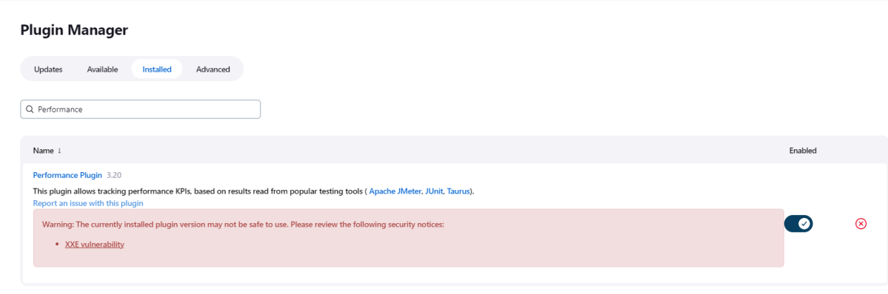

#### ***Step 2: Create a JMeter Script***

It is advisable to have a JMeter Script built and tested that it is working locally. To know how to create a JMeter Script, please refer to this tutorial – [***How to send POST requests in JMeter***](https://qaautomation.expert/2020/05/03/how-to-send-post-requests-in-jmeter/)***.***

#### ***Step 3: Create a new FreeStyle project***

1. *Give the****Name****of the project* – JMeter_Demo
2. *Click on the****FreeStyle project.***
3. *Click on the****OK****button.*

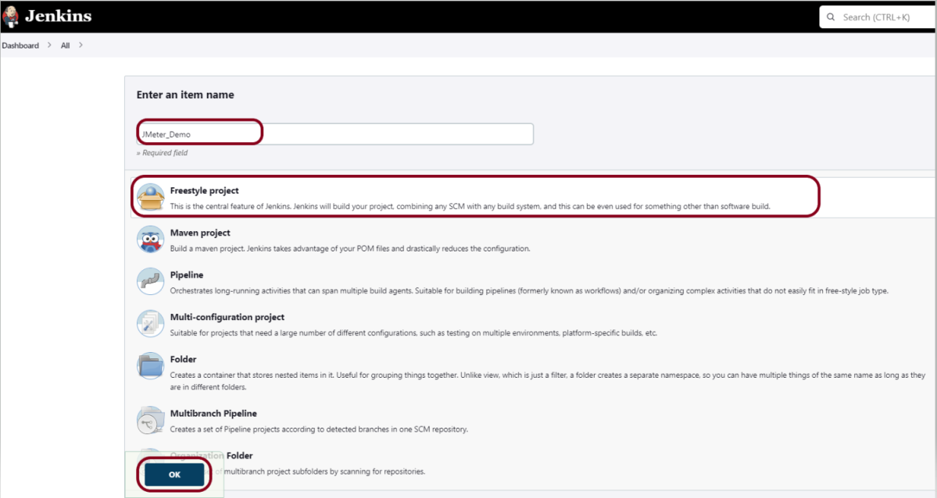

In the General section, enter the project ***description***in the Description box.

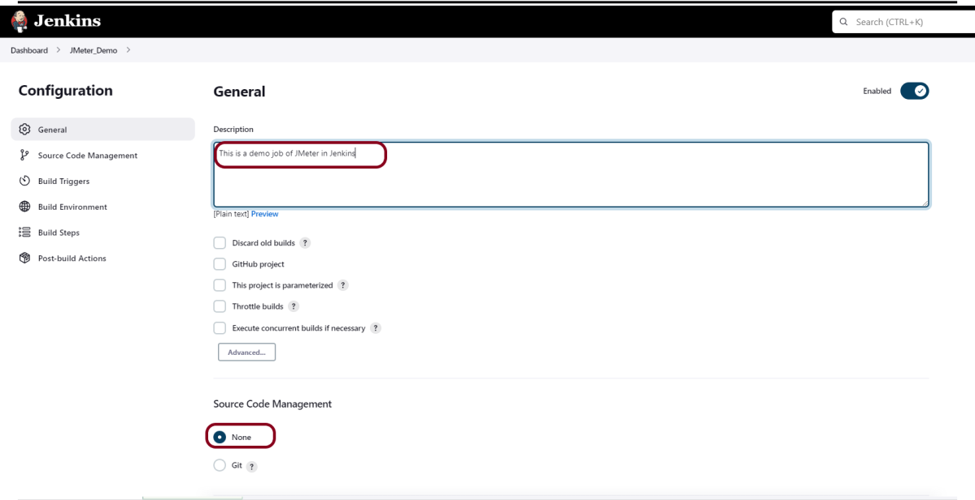

#### ***Step 4: Source Code Management***

Select ***Source Code Management as None***if the project is locally present on the machine.

#### ***Step 5: Select Execute Windows batch command***

In the Build Steps section, select ***Execute Windows batch command***.

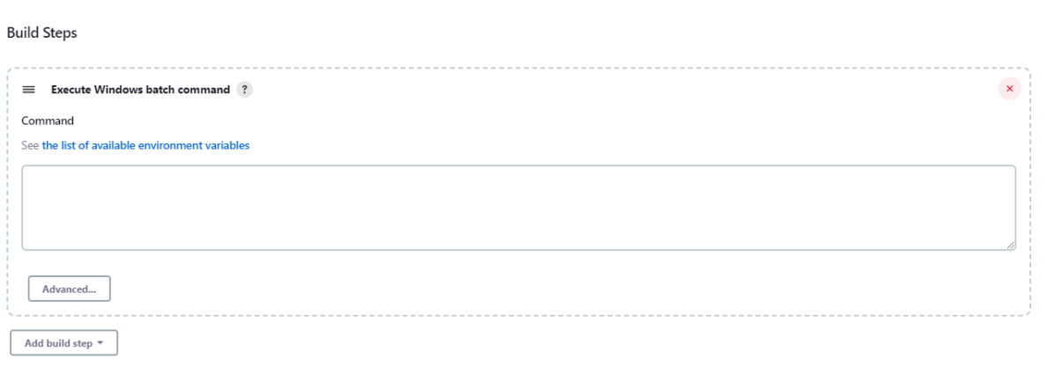

Use the below command to go to the path where the JMeter is placed in your system.

|  |  |
| --- | --- |
| 1  2  3 | cd C:\Users\Vibha\Documents\Vibha\Automation\apache-jmeter-5.6\apache-jmeter-5.6\bin    jmeter -n -t C:\Users\Vibha\Documents\Vibha\Automation\apache-jmeter-5.6\apache-jmeter-5.6\bin\POST_Demo.jmx -l C:\Users\Vibha\Documents\Vibha\Automation\apache-jmeter-5.6\apache-jmeter-5.6\results\result1.jtl |

In the above command, we are executing the JMeter Script – POST_Demo.jmx as well as generating a result1.jtl file in the folder results.

#### ***Step 6: Select “Publish Performance test result report” from “Post Build Actions”***

Scroll down to ‘***Post Build Actions***’ and click on the ‘***Add Post Build Actions***’ drop-down list. Select “**Publish Performance test result report.**“.

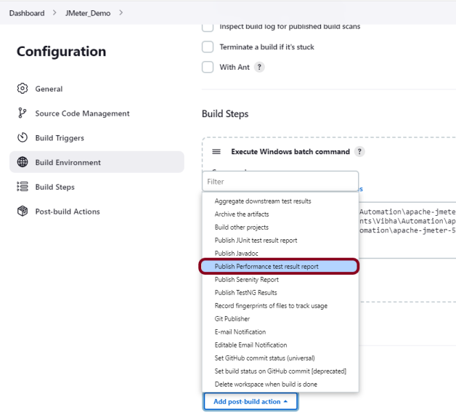

Enter the ***Source data files*** as the path in workspace where the report will be saved .

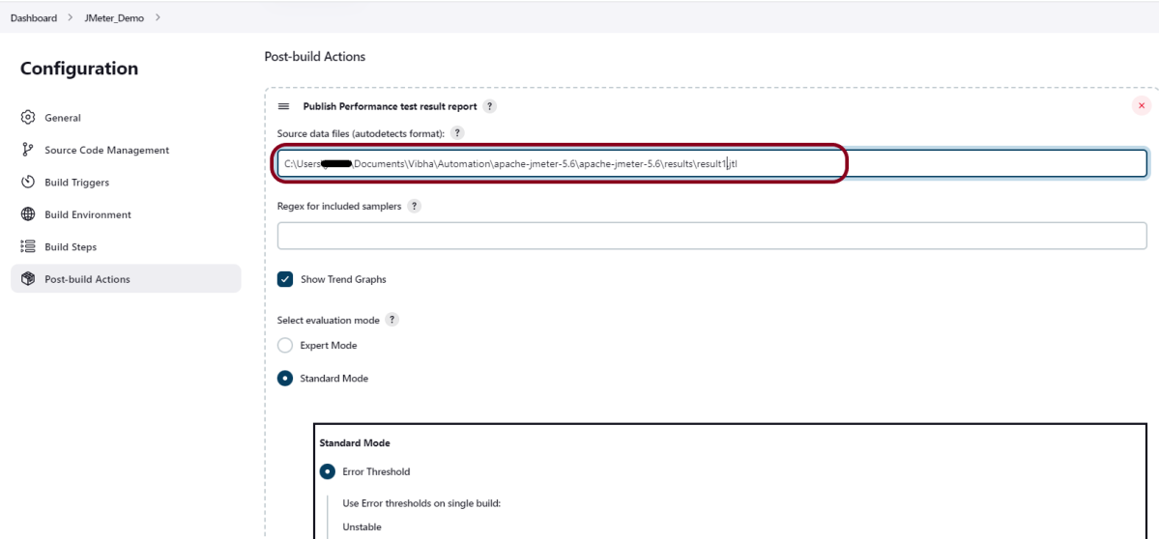

Click on the ***Apply***and ***Save***buttons.

We have created a new project **“*JMeter_Demo***” with the configuration to run the JMeter and also to generate JMeter Reports after execution using Jenkins.

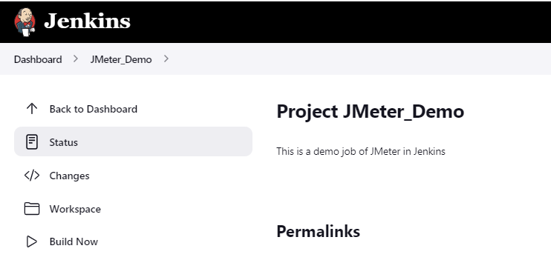

#### ***Step 7: Execute the tests***

Let’s execute it now by clicking on the “***Build Now***” button.

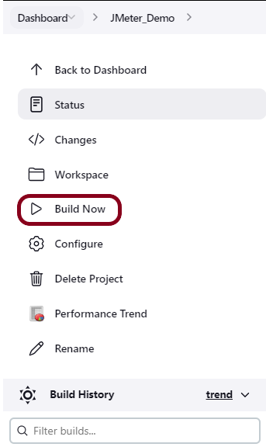

***Right-click*** on Build Number (here in my case it is #1).

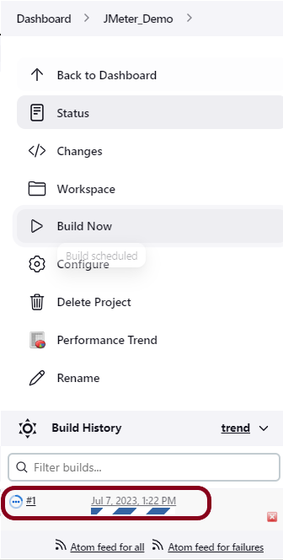

Click on ***Console Output*** to see the result.

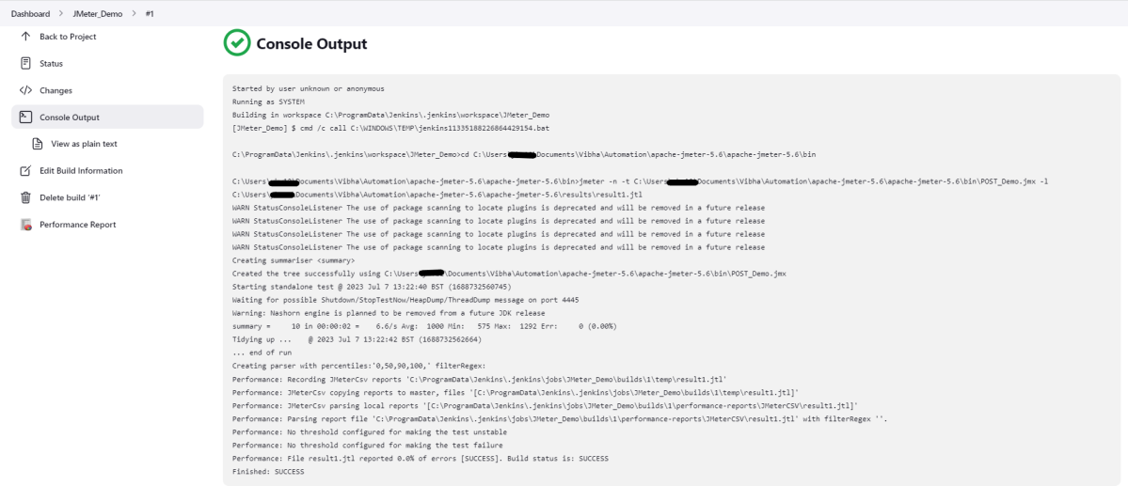

#### ***Step 8: View the Performance Report***

Once the execution is completed, we could see a link to view the ‘***Performance Report***’.

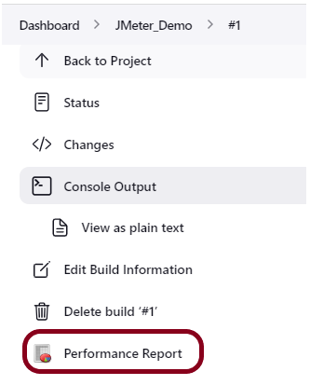

Click on the ***Performance Report***. It displays the summary of the tests.

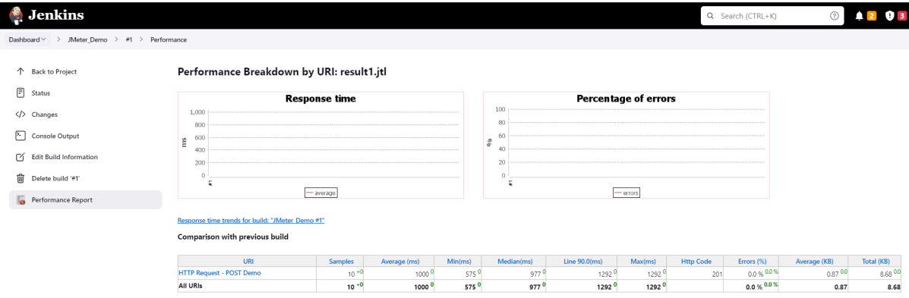

Congratulations on making it through this tutorial and hope you found it useful! Happy Learning!! Cheers!!